A CRM APPLICATION FOR THECHAISHOP&CO
5. Project Development Phase

Project & Team Details
Attribute | Details
Project Title | A CRM Application for TheChaiShop&Co
Domain | Cloud Computing / Salesforce Administration
Platform | Salesforce Lightning Developer Edition
Institution | PS PT MGR Government Arts & Science College, Sirkali, Puthur - 609108 (College Code: ANM403)
Submission Portal | SkillWallet
Team Leader | PRITHIVIRAJ R - (Reg. No. 24134031802521033)
Member 2 | Dharun Mass - (Reg. No. 24134031802521016)
Member 3 | Ajan A - (Reg. No. 24134031802521006)
Member 4 | Sanjai D - (Reg. No. 24134031802521041)
Member 5 | Vigneswaran C - (Reg. No. 24134031802521055)

User Story
As a sales representative at TheChaiShop&Co, I want to efficiently manage customer relationships and streamline sales processes using our CRM application. I want to easily access and update employer details, as well as distinguish between online and offline customer records using record types, allowing for personalized interactions. Additionally, I need the application to automate sales calculations, such as order quantity and total bill amount, to ensure accurate and efficient transactions. Moreover, I require the ability to generate insightful reports and dashboards to summarize and analyze sales data effectively, aiding in decision-making and strategy development. Lastly, I would like the application to automate email notifications to customers on their birthdays, informing them of special offers tailored to celebrate their special day, enhancing customer engagement and loyalty.

1. INTRODUCTION

1.1 Project Overview
The project "A CRM Application for TheChaiShop&Co" focuses on developing a Salesforce-based Customer Relationship Management (CRM) system to manage customer, employer, and enterprise accounts efficiently. The system automates sales processes, maintains customer records, generates reports, and improves customer engagement through automated notifications.

1.2 Purpose
The primary objectives of this project are:
- Streamline customer relationship management across counter sales and bulk orders.
- Automate billing and order calculations using declarative tools.
- Improve business data accuracy through field-level validations.
- Enable data-driven decision-making via real-time summary reports and interactive dashboards.
- Enhance customer engagement and retention through scheduled birthday email notifications.

5. PROJECT DEVELOPMENT & IMPLEMENTATION PHASE

5.1 Project Development Roadmap
The project development and implementation process consists of twelve structured milestones covering Salesforce account setup, custom data architecture, application configuration, declarative automation, data validation, customer communication, reporting, and executive dashboards.
- Milestone 1: Salesforce Developer Account Creation
- Milestone 2: Custom Objects Creation
- Milestone 3: Custom Tabs Configuration
- Milestone 4: The Lightning App Creation
- Milestone 5: Global Picklist Value Sets
- Milestone 6: Fields, Relationships & Declarative Formulas
- Milestone 7: Page Layouts Customization
- Milestone 8: Record Types Implementation
- Milestone 9: Data Validation Rules
- Milestone 10: Email Templates & Workflow Alerts
- Milestone 11: Schedule-Triggered Flow Automation
- Milestone 12: Reports & Executive Dashboards

5.2 Implementation Milestones

Milestone 1: Salesforce Developer Account Creation
A free Salesforce Developer Edition org was registered for developing and configuring the CRM application.
- Registered a free Developer Edition org at https://developer.salesforce.com/signup.
- Filled out user profile information, completed verification via email, and established administrator credentials.
- Successfully redirected to the Salesforce Setup Home interface.

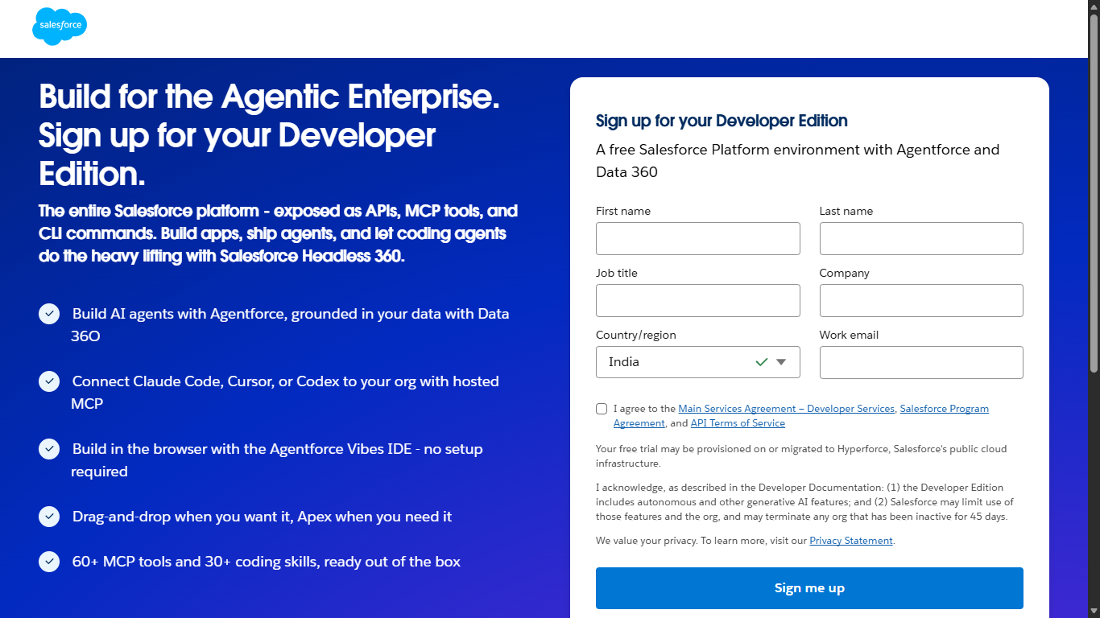

Milestone 2: Custom Objects Creation
Navigated to Setup → Object Manager → Create Custom Object to configure three primary custom objects with Search, Track Field History, Allow Activities, and Reports enabled:
- Employer Account (Employer_Account__c): Stores internal staff and management personnel data.
- Customer Account (Customer_Account__c): Captures walk-in and online customer transactions.
- Enterprise Account (Enterprise_Account__c): Manages corporate client accounts and bulk contracts.

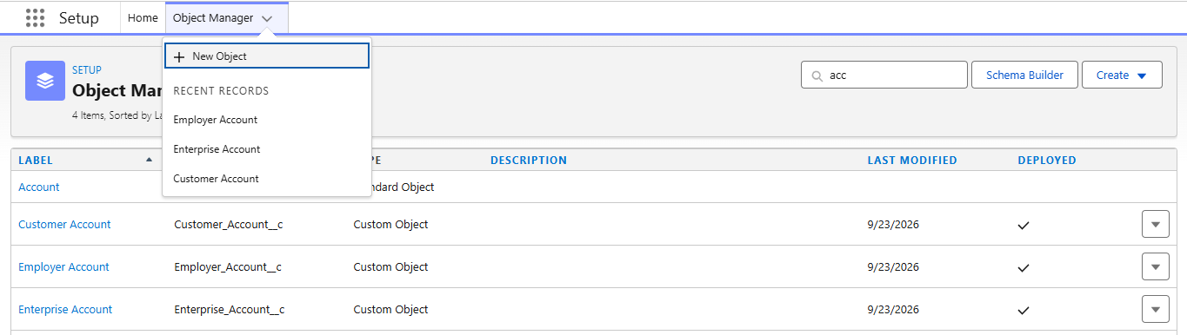

Milestone 3: Custom Tabs Configuration
Under Setup → User Interface → Tabs, configured dedicated navigation tabs:
- Customer Accounts: Tab Style – Presenter / People
- Employer Accounts: Tab Style – Building Block
- Enterprise Accounts: Tab Style – Form / Apple

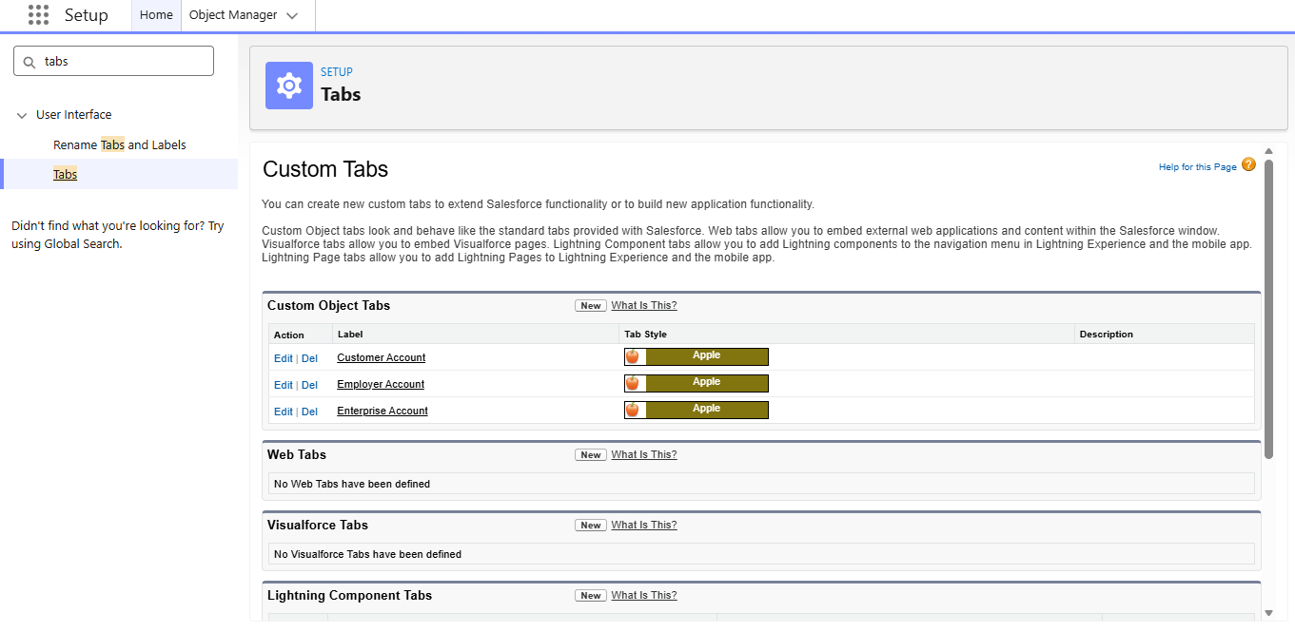

Milestone 4: The Lightning App Creation
Using Lightning App Manager, configured a dedicated workspace:
- App Name: TheChaiShop&Co
- Navigation Style: Standard Navigation
- Supported Form Factors: Desktop and Phone
- Navigation Items: Customer Accounts, Employer Accounts, Enterprise Accounts, Reports, Dashboards.
- User Profile Access: System Administrator.

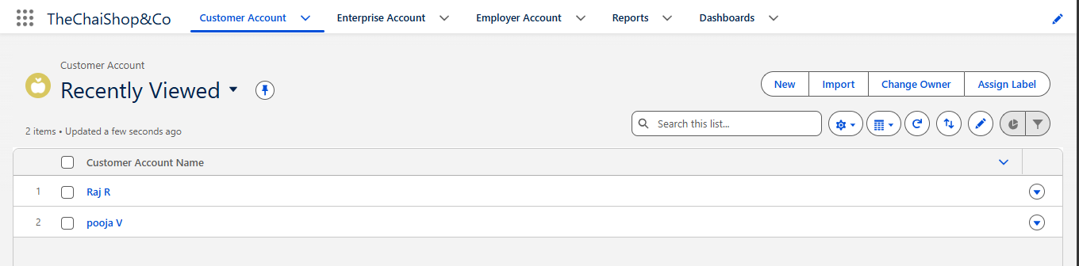

Milestone 5: Global Picklist Value Sets
Under Setup → Picklist Value Sets, created standardized picklist sets across objects:
Gender: Male, Female, Others
Payment Mode: Cash, Gpay, PhonePe, Paytm, Credit or Debit card
Type of Items: Tea powder, Cookies, Gift Hampers
Items: Platinum Tea Powder, Double Delight Tea Powder, Super Dust Tea Powder, Osmania Biscuits (Value Pack), Osmania Biscuits (Premium Pack), Dry Fruit Biscuits, Fruit Biscuits, Salt Biscuits, Multigrain Biscuits, Ragi Biscuits, Double Choco Chip Cookies, Butter Almond Cookies, Melting Moments Cookies, Honey Oats Cookies, Delight Box, Signature Box, Assorted Box

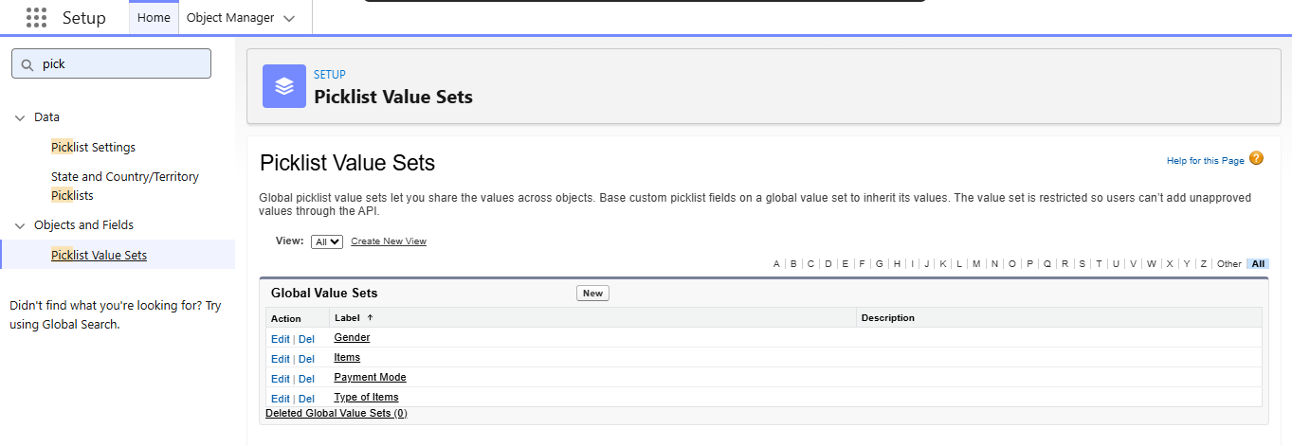

Milestone 6: Fields, Relationships & Declarative Formulas
Custom Fields for Customer Account (Customer_Account__c):
Field | Configuration
First_Name__c, Last_Name__c | Text, 25, Required
Phone_Number__c | Phone, Required
Email_ID__c | Email, Required
Date_of_Birth__c | Date, Required
Gender__c | Picklist, Global Set: Gender
Address__c | Text, 125
Type_of_Items__c | Multi-Select Picklist, Global: Type of Items
Products_purchased__c | Multi-Select Picklist, Global: Items
Chai__c | Multi-Select Picklist: TheChaiShop&Co Special Tea, Single Tea, Masala Tea, Lemon Tea, Ginger Tea, Green Tea, Sugar Free Tea
Payment_Mode__c | Picklist, Global: Payment Mode
Associated_Employer__c | Lookup Relationship to Employer_Account__c
Declarative Formula Configurations:
Date of Birthday is today? (Date_of_Birthday_is_today__c)
- Formula Return: Checkbox
IF(
AND(
DAY(TODAY()) = DAY(Date_of_Birth__c),
MONTH(TODAY()) = MONTH(Date_of_Birth__c)
),
TRUE,
FALSE
)
Order Quantity (Order_Quantity__c)
- Formula Return: Number
Dynamically calculates item count across selected items using IF(INCLUDES(...), 1, 0) expressions.
Total Bill (Total_Bill__c)

- Formula Return: Number / Currency
IF(INCLUDES(Products_purchased__c, "Platinum Tea Powder"), 175, 0) +
IF(INCLUDES(Products_purchased__c, "Double Delight Tea Powder"), 150, 0) +
IF(INCLUDES(Products_purchased__c, "Super Dust Tea Powder"), 125, 0) +
IF(INCLUDES(Products_purchased__c, "Osmania Biscuits (Value Pack)"), 50, 0) +
IF(INCLUDES(Products_purchased__c, "Osmania Biscuits (Premium Pack)"), 80, 0) +
IF(INCLUDES(Products_purchased__c, "Dry Fruit Biscuits"), 110, 0) +
IF(INCLUDES(Products_purchased__c, "Fruit Biscuits"), 160, 0) +
IF(INCLUDES(Products_purchased__c, "Salt Biscuits"), 110, 0) +
IF(INCLUDES(Products_purchased__c, "Multigrain Biscuits"), 170, 0) +
IF(INCLUDES(Products_purchased__c, "Ragi Biscuits"), 190, 0) +
IF(INCLUDES(Products_purchased__c, "Double Choco chip Cookies"), 200, 0) +
IF(INCLUDES(Products_purchased__c, "Butter Almond Cookies"), 110, 0) +
IF(INCLUDES(Products_purchased__c, "Melting Moments Cookies"), 150, 0) +
IF(INCLUDES(Products_purchased__c, "Honey Oats Cookies"), 160, 0) +
IF(INCLUDES(Products_purchased__c, "Delight Box"), 850, 0) +
IF(INCLUDES(Products_purchased__c, "Signature Box"), 1500, 0) +
IF(INCLUDES(Products_purchased__c, "Assorted Pack"), 600, 0) +
IF(INCLUDES(Chai__c, "TheChaiShop&Co Special Tea"), 70, 0) +
IF(INCLUDES(Chai__c, "Single Tea"), 50, 0) +
IF(INCLUDES(Chai__c, "Masala Tea"), 60, 0) +
IF(INCLUDES(Chai__c, "Lemon Tea"), 40, 0) +
IF(INCLUDES(Chai__c, "Ginger Tea"), 55, 0) +
IF(INCLUDES(Chai__c, "Green Tea"), 45, 0) +
IF(INCLUDES(Chai__c, "Sugar Free Tea"), 55, 0)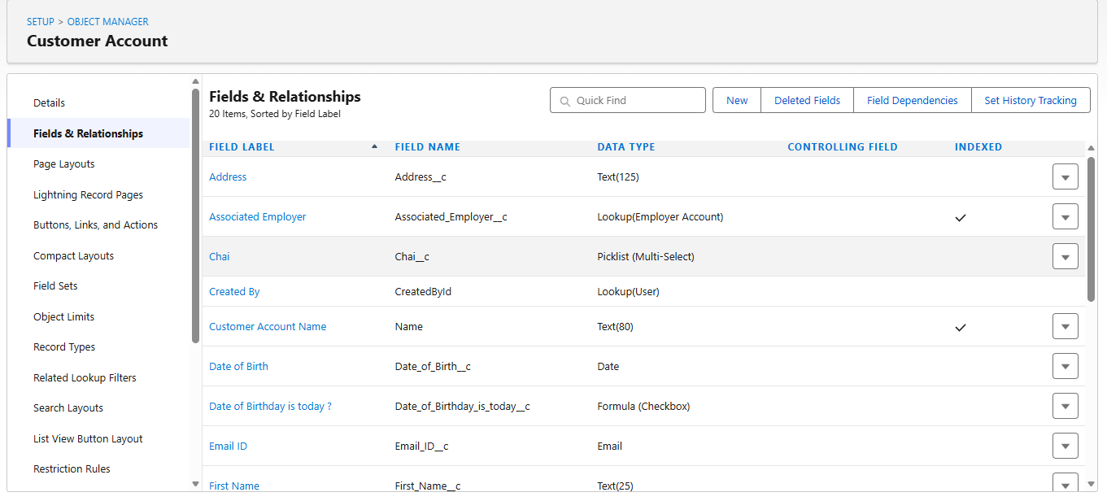

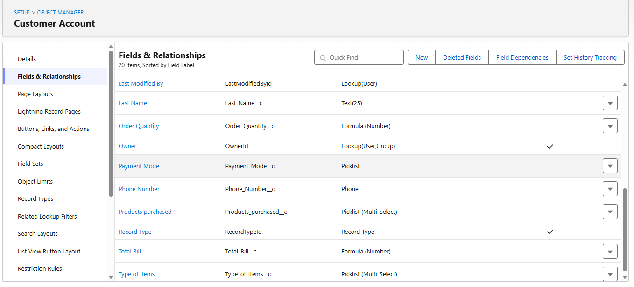

Milestone 7: Page Layouts Customization
Customized Page Layouts to support the different customer order workflows:
- Online Orders Layout: Configured for packaged shipments and delivery addresses.
- Walk-In Orders Layout: Tailored with immediate tea choices (Chai__c) and cash/digital counter payment methods.

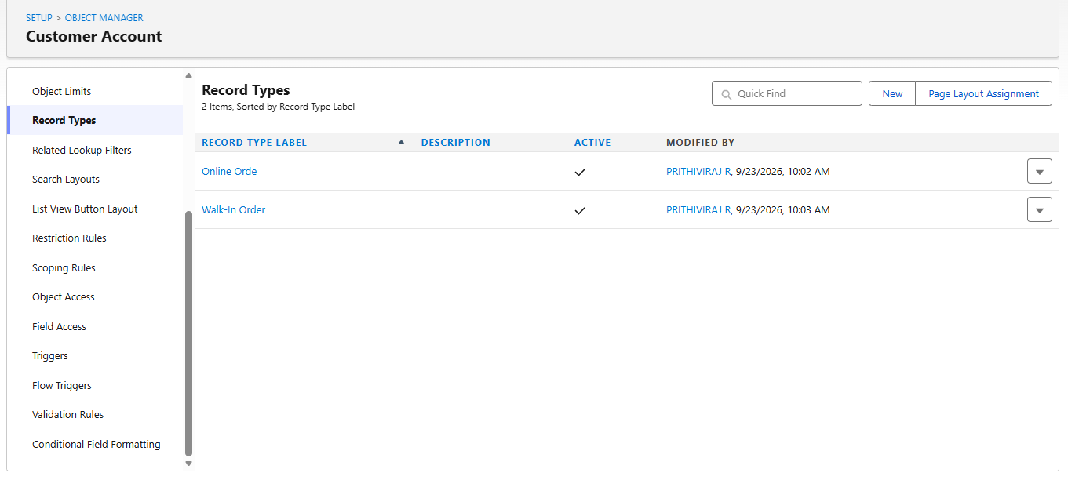

Milestone 8: Record Types Implementation
Configured two specialized Record Types under Customer Account:
- Online Order
- Walk-In Order
- Mapped Profile Record Type Settings under System Administrator to enable seamless creation of both record types.

Milestone 9: Data Validation Rules
Configured validation rules to enforce data integrity:
- Object: Customer Account, Employer Account, Enterprise Account
- Rule Name: Phone_Number
Error Condition Formula:
AND(
NOT(ISBLANK(Phone_Number__c)),
NOT(REGEX(Phone_Number__c, "^[1-9]{10}$")),
NOT(REGEX(Phone_Number__c, "^\\d+$"))
)
- Error Message: "The phone number field must not be blank. The phone number must consist of exactly 10 digits."

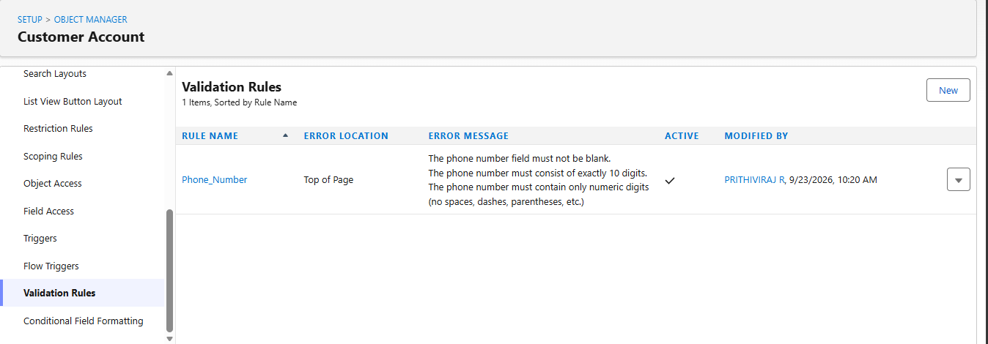

Milestone 10: Email Templates & Workflow Alerts
- Classic Text Email Template: Birthday Offer Email
- Template Name: Birthday Offer Email
- Subject: Special Birthday Offer Inside!
- Body Highlights: Delivers a birthday greeting to {!Customer_Account__c.First_Name__c} with an exclusive 50% discount coupon code: [HBDAY50].
- Workflow Email Alert: Happy Birthday email alert
- Object: Customer Account
- Recipient Type: Email Field: Email_ID__c

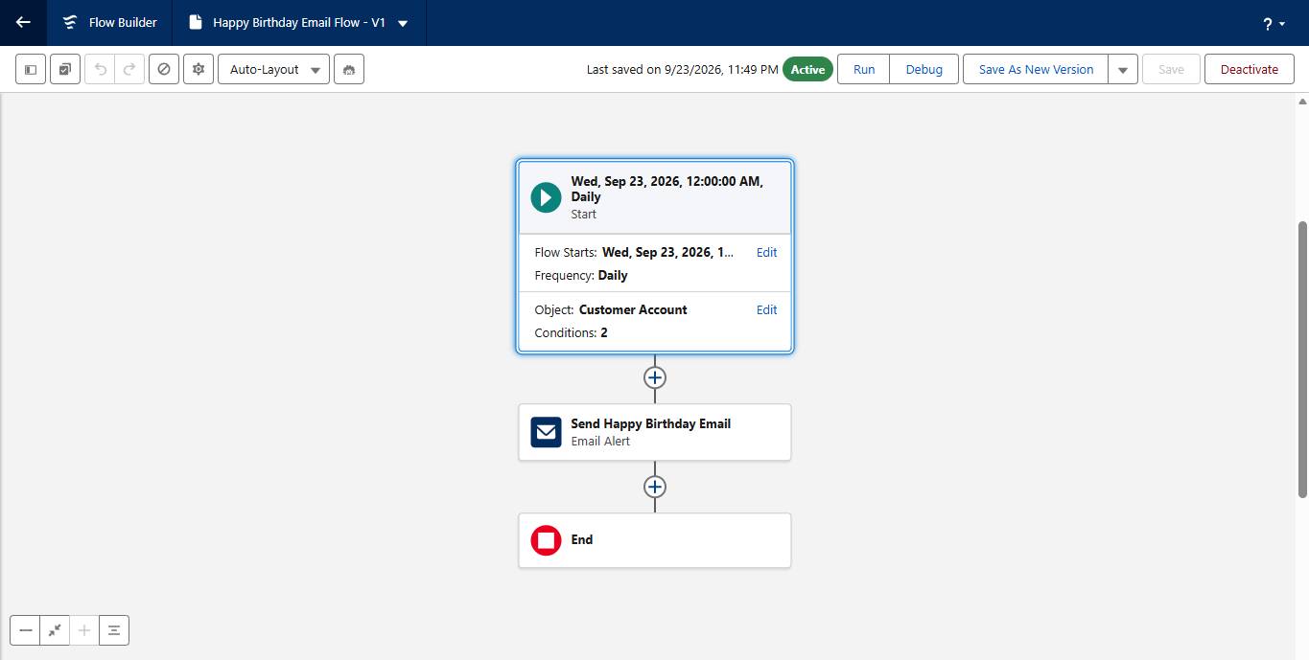

Milestone 11: Schedule-Triggered Flow Automation
Using Salesforce Flow Builder, configured a background automation:
- Flow Type: Schedule-Triggered Flow
- Schedule: Starts Daily at 12:00 AM
- Target Object: Customer Account
- Filter Conditions: Date_of_Birthday_is_today__c Equals True; Email_ID__c Is Null False
- Action Element: Calls Happy Birthday email alert passing {!$Record.Id}.
- Status: Saved as Happy Birthday Email Flow - V1 and Activated.

Milestone 12: Reports & Executive Dashboards
Configured reports and a master dashboard to summarize and visualize sales data:
- Customer Account Sales Report: Grouped by Customer Account: Record Type calculating record count, sum of order quantities, and total billing amounts.
- Enterprise Account Sales Report: Grouped by Type of Items summarizing corporate procurement.
- Master Dashboard (Customer Vs Enterprise Sales).
- Component 1: Horizontal Bar Chart displaying retail order breakdown by Record Type.
- Component 2: Donut Chart displaying corporate sales metrics categorized by product groups.

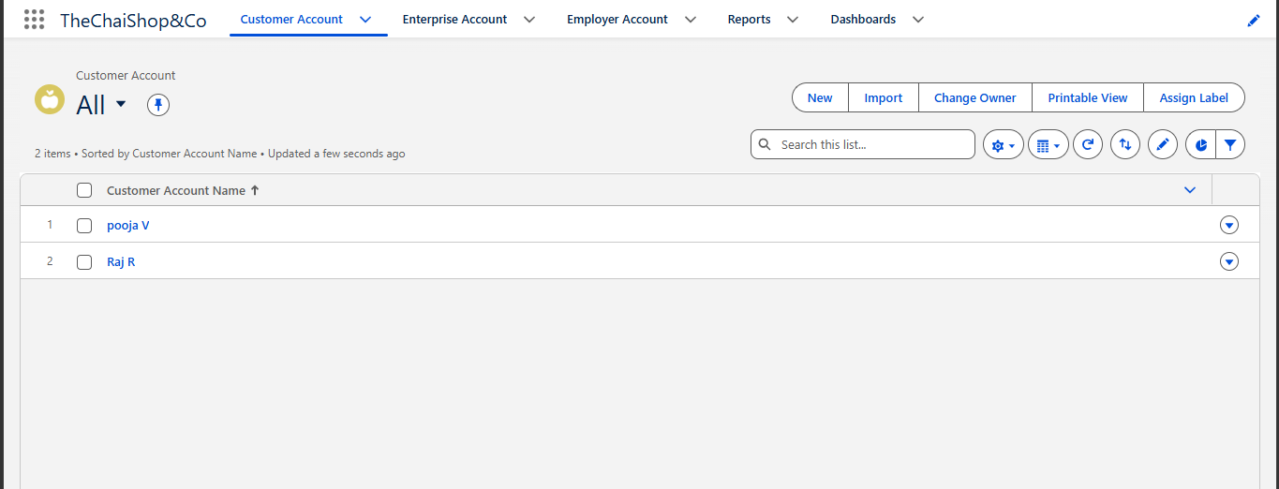

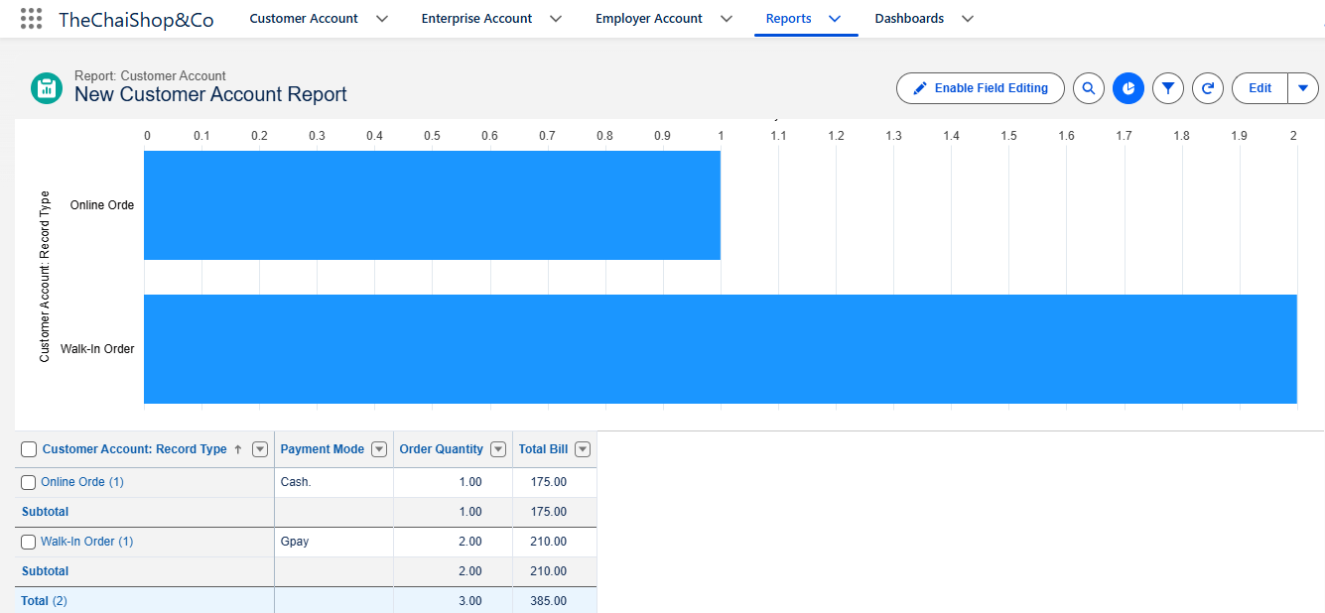

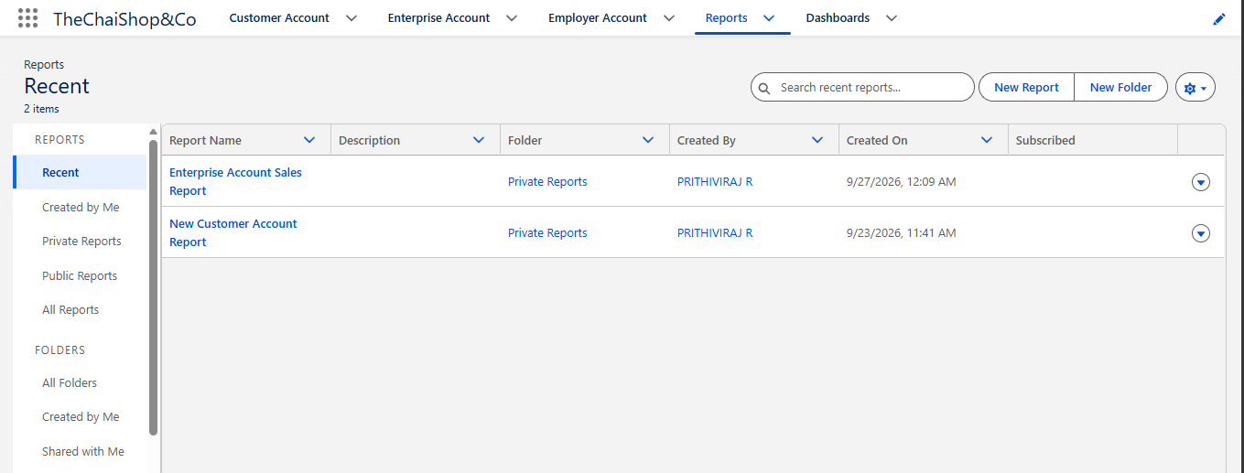

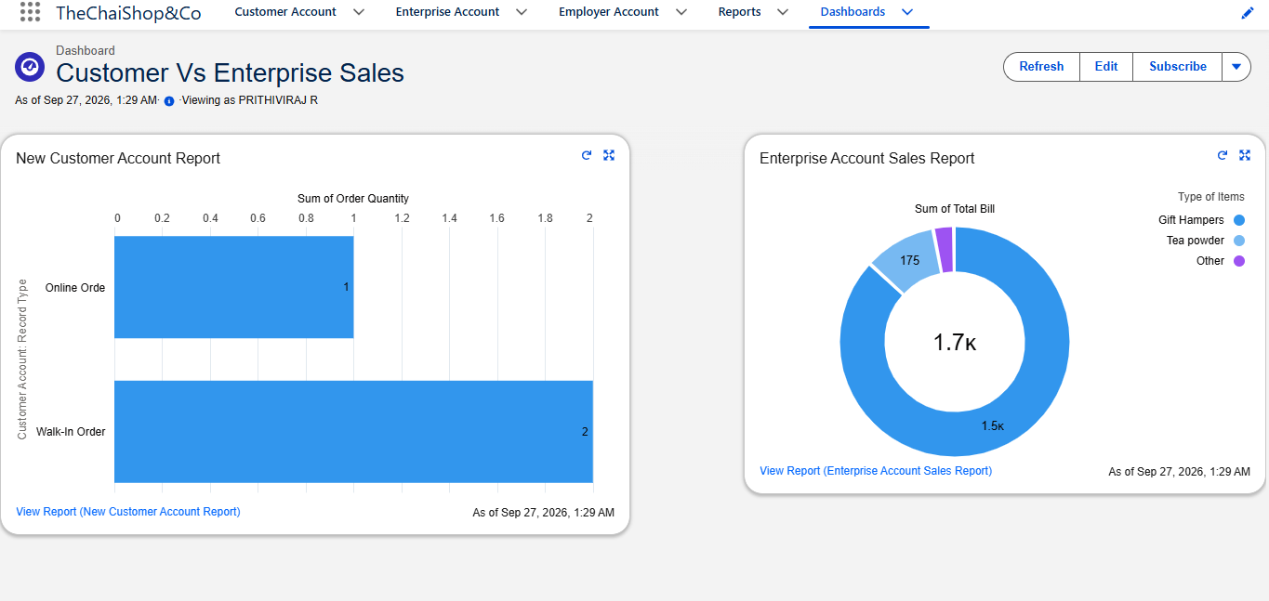

5.3 Project Development Summary
The TheChaiShop&Co CRM Application was developed using Salesforce Lightning Developer Edition through a structured twelve-milestone implementation process. The implementation integrates custom objects, custom tabs, a dedicated Lightning app, Global Picklist Value Sets, fields and relationships, declarative formulas, page layouts, record types, validation rules, email templates, workflow alerts, Schedule-Triggered Flow automation, reports, and executive dashboards.
The completed configuration provides a centralized CRM environment for managing customer, employer, and enterprise accounts while supporting order processing, automated billing calculations, customer communication, and sales analysis.

5.4 Expected Outcomes
- Centralized management of customer, employer, and enterprise account information.
- Standardized data entry through Global Picklist Value Sets.
- Improved business data accuracy through validation rules.
- Automated order quantity and total bill calculations using declarative formulas.
- Separate handling of Online Order and Walk-In Order records through Record Types and Page Layouts.
- Automated birthday communication through Email Templates, Workflow Email Alerts, and Schedule-Triggered Flow.
- Improved sales visibility through Reports and the Customer Vs Enterprise Sales dashboard.

